We have reached the knock-out phase of Euro 2020 (or 2021) where the final-16 teams and the games can be shown below:

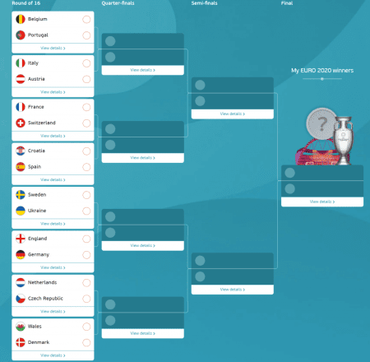

The question is who is going to be the Euro 2020 Winner. Although we cannot predict the Winner, we can estimate the probabilities of each team to win the Euro.

**The Methodology**

This is a very simple model that is based on [UEFA Ranking](https://www.fifa.com/fifa-world-ranking/mens-ranking?dateId=id13295). Our assumption is that each team follows the Normal Distribution, with **mean** its corresponding **ranking** and **standard deviation** the (max ranking – min ranking)/6. Regarding the standard deviation, we assumed that the UEFA teams are coming from the same distribution where the standard deviation can be estimated from the 6 sigma rule.

UEFA Ranking

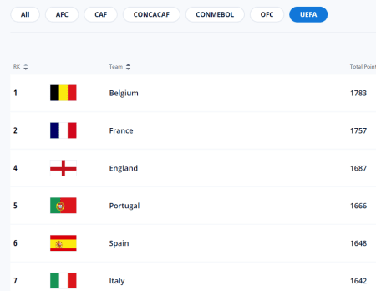

Finally, once we define the distribution of each team, we will simulate the results of Round 16 and we will estimate the Winner.

**The Code**

We will work in R and we will run **10000** simulations.

# get the UEFA Ranking

ranking<-list(bel=1783,

fra=1757,

eng=1687,

por=1666,

esp=1648,

ita=1642,

den=1632,

ger=1609,

sui=1606,

cro=1606,

net=1598,

wal=1570,

swe=1570,

aus=1523,

ukr=1515,

cze=1459)

# get the range of the max UEFA ranking (Belgium) minus the minimum (San Marino) and devide it by 6

# assuming that 6 sigma is the range

stdev<-(1783-805)/6

sim_champion<-c()

for (i in 1:10000) {

#######################

#### Final 16

#######################

# game bel vs por

teams_game1<-c("bel","por")

game1<-rnorm(1, ranking[[teams_game1[1]]], stdev)>rnorm(1, ranking[[teams_game1[2]]], stdev)

if (game1) {

qualified_game1<-teams_game1[1]

} else {

qualified_game1<-teams_game1[2]}

qualified_game1

# game ita vs aus

teams_game2<-c("ita","aus")

game2<-rnorm(1, ranking[[teams_game2[1]]], stdev)>rnorm(1, ranking[[teams_game2[2]]], stdev)

if (game2) {

qualified_game2<-teams_game2[1]

} else {

qualified_game2<-teams_game2[2]}

qualified_game2

# game fra vs sui

teams_game3<-c("fra","sui")

game3<-rnorm(1, ranking[[teams_game3[1]]], stdev)>rnorm(1, ranking[[teams_game3[2]]], stdev)

if (game3) {

qualified_game3<-teams_game3[1]

} else {

qualified_game3<-teams_game3[2]}

qualified_game3

# game cro vs esp

teams_game4<-c("cro","esp")

game4<-rnorm(1, ranking[[teams_game4[1]]], stdev)>rnorm(1, ranking[[teams_game4[2]]], stdev)

if (game4) {

qualified_game4<-teams_game4[1]

} else {

qualified_game4<-teams_game4[2]}

qualified_game4

# game swe vs ukr

teams_game5<-c("swe","ukr")

game5<-rnorm(1, ranking[[teams_game5[1]]], stdev)>rnorm(1, ranking[[teams_game5[2]]], stdev)

if (game5) {

qualified_game5<-teams_game5[1]

} else {

qualified_game5<-teams_game5[2]}

qualified_game5

# game eng vs ger

teams_game6<-c("eng","ger")

game6<-rnorm(1, ranking[[teams_game6[1]]], stdev)>rnorm(1, ranking[[teams_game6[2]]], stdev)

if (game6) {

qualified_game6<-teams_game6[1]

} else {

qualified_game6<-teams_game6[2]}

qualified_game6

# game net vs cze

teams_game7<-c("net","cze")

game7<-rnorm(1, ranking[[teams_game7[1]]], stdev)>rnorm(1, ranking[[teams_game7[2]]], stdev)

if (game7) {

qualified_game7<-teams_game7[1]

} else {

qualified_game7<-teams_game7[2]}

qualified_game7

# game wal vs den

teams_game8<-c("wal","den")

game8<-rnorm(1, ranking[[teams_game8[1]]], stdev)>rnorm(1, ranking[[teams_game8[2]]], stdev)

if (game8) {

qualified_game8<-teams_game8[1]

} else {

qualified_game8<-teams_game8[2]}

qualified_game8

#######################

#### Final 8

#######################

teams_f8_1<-c(qualified_game1,qualified_game2)

game_f8_1<-rnorm(1, ranking[[teams_f8_1[1]]], stdev)>rnorm(1, ranking[[teams_f8_1[2]]], stdev)

if (game_f8_1) {

qualified_f8_1<-teams_f8_1[1]

} else {

qualified_f8_1<-teams_f8_1[2]}

qualified_f8_1

teams_f8_2<-c(qualified_game3,qualified_game4)

game_f8_2<-rnorm(1, ranking[[teams_f8_2[1]]], stdev)>rnorm(1, ranking[[teams_f8_2[2]]], stdev)

if (game_f8_2) {

qualified_f8_2<-teams_f8_2[1]

} else {

qualified_f8_2<-teams_f8_2[2]}

qualified_f8_2

teams_f8_3<-c(qualified_game5,qualified_game6)

game_f8_3<-rnorm(1, ranking[[teams_f8_3[1]]], stdev)>rnorm(1, ranking[[teams_f8_3[2]]], stdev)

if (game_f8_3) {

qualified_f8_3<-teams_f8_3[1]

} else {

qualified_f8_3<-teams_f8_3[2]}

qualified_f8_3

teams_f8_4<-c(qualified_game7,qualified_game8)

game_f8_4<-rnorm(1, ranking[[teams_f8_4[1]]], stdev)>rnorm(1, ranking[[teams_f8_4[2]]], stdev)

if (game_f8_4) {

qualified_f8_4<-teams_f8_4[1]

} else {

qualified_f8_4<-teams_f8_4[2]}

qualified_f8_4

#######################

#### Final 4

#######################

teams_f4_1<-c(qualified_f8_1,qualified_f8_2)

game_f4_1<-rnorm(1, ranking[[teams_f4_1[1]]], stdev)>rnorm(1, ranking[[teams_f4_1[2]]], stdev)

if (game_f4_1) {

qualified_f4_1<-teams_f4_1[1]

} else {

qualified_f4_1<-teams_f4_1[2]}

qualified_f4_1

teams_f4_2<-c(qualified_f8_3,qualified_f8_4)

game_f4_2<-rnorm(1, ranking[[teams_f4_2[1]]], stdev)>rnorm(1, ranking[[teams_f4_2[2]]], stdev)

if (game_f4_2) {

qualified_f4_2<-teams_f4_2[1]

} else {

qualified_f4_2<-teams_f4_2[2]}

qualified_f4_2

#######################

#### Final

#######################

teams_f<-c(qualified_f4_1,qualified_f4_2)

game_f<-rnorm(1, ranking[[teams_f[1]]], stdev)>rnorm(1, ranking[[teams_f[2]]], stdev)

if (game_f) {

champion<-teams_f[1]

} else {

champion<-teams_f[2]}

sim_champion<-c(sim_champion,champion)

}

prop.table(table(sim_champion))*100

**The Estimated Results**

After running 10,000 simulations, we get that **Belgium** is the most likely team to win the Euro 2020 with a **25.8%** probability followed by **France** (21%) and **England** (13%)

|  |  |
| --- | --- |
| **Team** | **Probability (%)** |
| Belgium | 25.82 |
| France | 21.17 |
| England | 13.18 |
| Denmark | 6.61 |
| Italy | 5.24 |
| Netherlands | 5.18 |
| Spain | 4.74 |
| Portugal | 4.66 |
| Germany | 3.76 |
| Sweden | 2.31 |
| Croatia | 2.14 |
| Wales | 2.1 |
| Switzerland | 1.91 |
| Ukraine | 0.78 |
| Austria | 0.22 |
| Czech Republic | 0.18 |

**The Estimated Odds from the Market/Bookmakers**

According to Bookmaker, the favorite to win the trophy is **France**, followed by **Italy** and **England**.

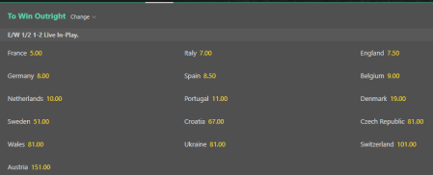

**My Suggestion**

Personally, I see mispricing in Bookmakers’ odds for Belgium that pays off 9 times (meaning an estimated probability to win the euro 11.11%). So my suggestion is to go with Belgium!